93.12.30
From Herbert Williamson
RB MSS M63, Library, Royal Botanic Gardens Melbourne.

Hawkesdale
Dec 30th 93
Baron Sir F. v Mueller,
Honoured Sir,
I hope that I am not troubling you too much these holiday times, but I have had a ramble around Mr Abrupt and have gathered some more specimens which I send per this post.
Re. my Grevillea It appears to be exceedingly rare. I came across one plant only, & this only after searching systematically for 4 hours round the spot where I remembered to have picked the specimens. I enclose a branch; please say if you would like more, as I have some. As to fruit — I searched carefully, and could find nothing that looked like ripe fruit I expected to find something similar to the dehiscent fruit of G. aquifolium which is very plentiful there, but all the flower stalks were bare as per sample enclosed as if all fruit had fallen, so I scraped up a large quantity of the rubbish below the shrub & searched this. In it I got a lot of what appear like shrivelled, barren, ovaries (enclosed in packet A)
Is it possible that the organs as per packet B are the developing fruit. As I found one with a turgid orange-yellow ball as large as a pin's head on I suspected it to be so. However I suppose it will all be plain to you. I regret that I lost the little ball; but if the others are still to develop, I can easily procure specimens in a month or so, as I pointed out the shrub to Mr Bolton of the Bee farm. I was around the spot several times afterwards, but could not find another plant.
Can it be that the plant has now no means of reproduction
The absence of fruit & the rareness of the plant seen to point to this.
Re No 25 in envelope
appears to me a glossostigma but has two stamens only
[Locality] sandy shore of small lake in Victoria valley.
I send you all I could find in the time at my disposal of Candollea sobolifera Chiefly fruiting
I sincerely trust that your lung affection has passed away or abated. I am sure my brother would feel well rewarded by a very brief reception he expected nothing more.
With kind wishes for your health & prosperity in the coming year
I am
Yours respectfully
H. B. Williamson

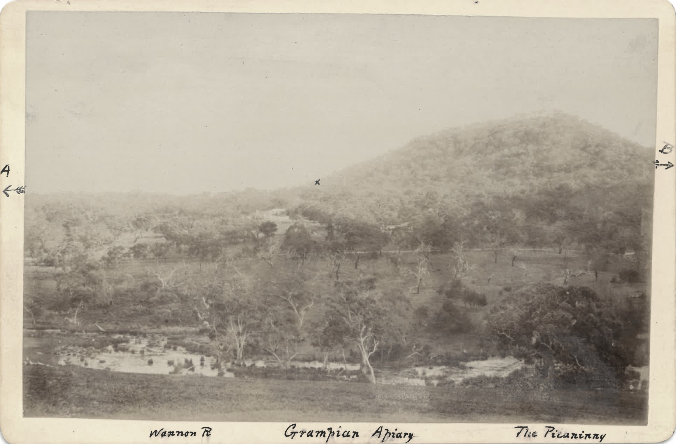

Candollea sobolifera
Glossostigma
Grevillea aquifolium

MS found with specimen of Grevillea williamsonii (MEL 75247A). M named the species in honour of Williamson in B93.12.02.
Vic.
Vic.
See two notes from M to H. Williamson, October 1893 (in this edition as 93-10-00 and 93-10-00a respectively).
MS has 'A' marked here to identify the specimen being referred to.
Packets A and B not found.
In B88.11.02, p. 84, M lists Glossostigma with 4 anthers.
editorial addition — MS damaged.
There are 5 specimens with a Williamson collecting number 25 for 1893 in MEL; only MEL 2080623, Spyridium vexilliferum, is said to be from Mt Abrupt, which is to the east of Victoria Valley.
See M to H. Williamson, 28 December 1893.
File contains a photograph captioned: 'Wannon R. Grampian Apiary The Picaninny'. On the back Williamson has written: 'This shows "The Picaninni" a hill between Mt Abrupt and Mt Sturgeon — Mt Sturgeon ½ mile in direction A [marked with an arrow pointing, on the front of the photo to the left] Mt Abrupt 1 mile in direction B [marked with an arrow pointing, on the front of the photo to the right]. Mr Bolton's Bee farm in centre. Little cross above the apiary shows where I found Grevillea Williamsoni These picture are my own work & I send them thinking they may interest you. H B Williamson'. The file contains only the annotated photograph: 93-12-30_image01.jpg M evidently received the photograph earlier than the letter with which it is now filed; see M to H. Williamson, 28 December 1893.

